# **ServiceNow Catalog Item Documentation**

## **Laptop Request Catalog Item**

## **Main Objective:**

To create a **Service Catalog item** in ServiceNow for employees to request laptops in a streamlined, user-friendly, and efficient manner, replacing the current manual process.

## **Project Description:**

The goal of this project is to develop a **dynamic ServiceNow catalog item** titled "**Laptop Request**" that will allow employees to request a laptop with minimal effort and maximum accuracy. The form should use **UI policies and UI actions** to guide user input, hide/show relevant fields dynamically, and reset the form as needed.

Additionally, the solution should be **deployment-ready**, with change tracking in place to meet governance and audit requirements.

EXPLAINATION ABOUT PROJECT STEP BY STEP:

UPDATE SET:

**Create Local Update set**

1. Open service now.
2. Click on All >> search for update sets
3. Select local update sets under system update sets
4. Click on new
5. Fill the following details to create a update set as: “Laptop Request”
6. Click on submit and make current.
7. By clicking on the button it activates the update set .

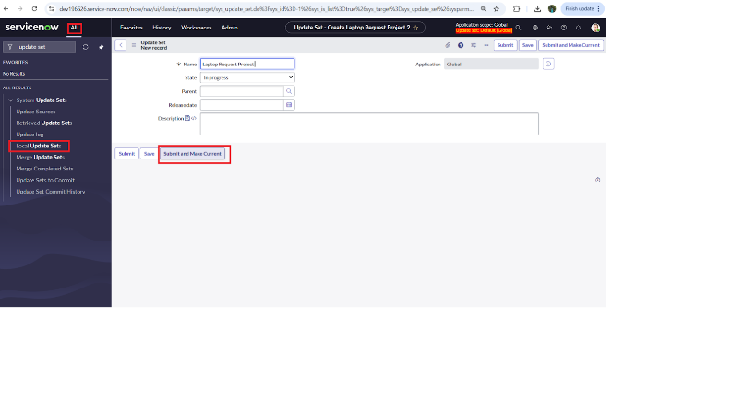

**Service Catalog Item:**

Create Service Catalog Item

1. Open service now.
2. Click on All >> service catalog
3. Select maintain items under catalog definitions
4. 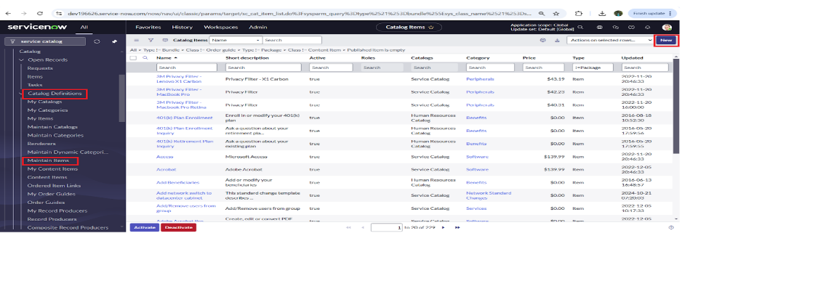Click on New.
5. Fill the following details to create a new catalog item

            Name: Laptop Request

            Catalog: service Catalog

            Category: Hardware

            Short Description: Use this item to request a new laptop

1. Click on ‘SAVE’

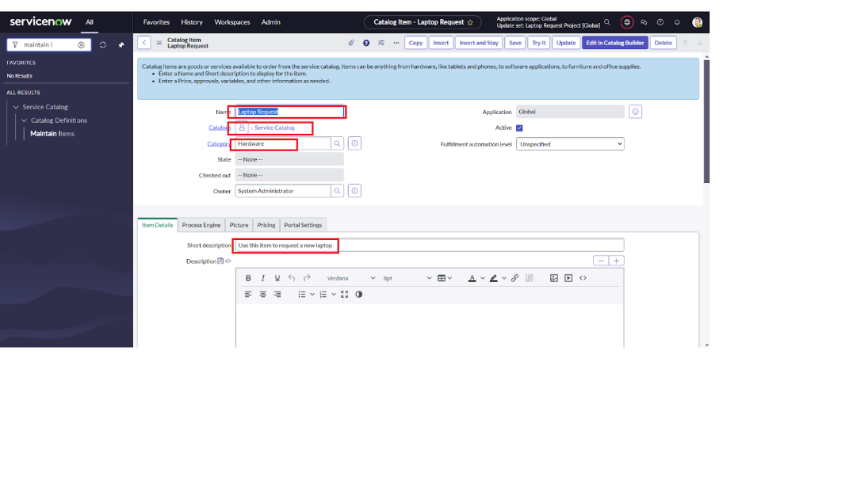

**Add variables**

**Step1:**

* After saving the catalog item form scroll down and click on variable (related list)
* Click on new and enter the details as below

1. Variable 1: Laptop Model

             Type: Single line text

             Name: laptop model

             Order:100

* Click on submit
* Again, click on new and add Remaining variables in the above process

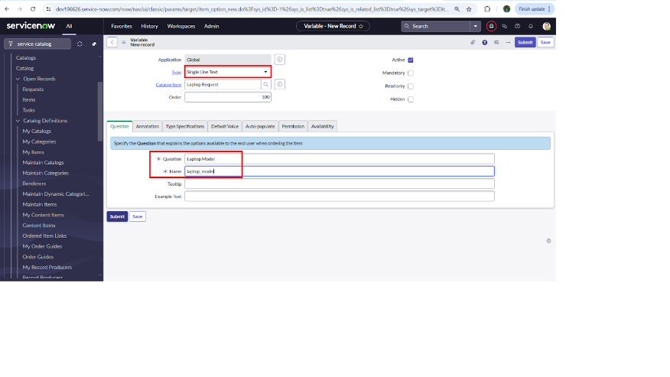

2. Variable 2:Justification

             Type: Multi line text

             Name: justification

             Order:200

     3. Variable 3:Additional Accessories

             Type: Checkbox

             Name: additional_accessories

             Order:300

     4. Variable 4: Accessories Details

             Type: Multi line text

             Name:accessories_details

             Order:400

**Step2:**

* After adding above variable which are added to newly created catalog item
* 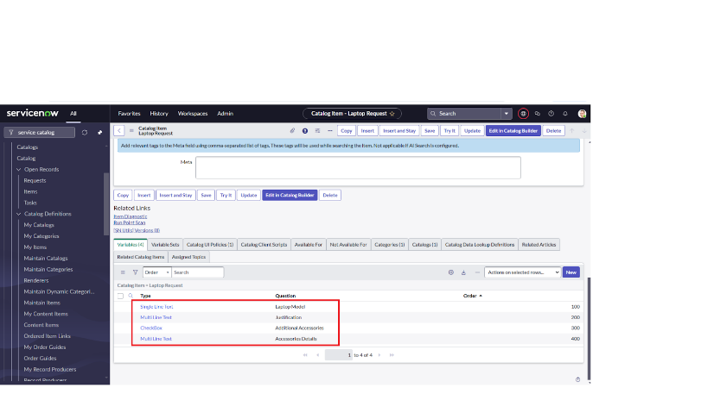Then save the catalog item form

### **UI Policy:**

**Create Catalog Ui policies**

1. Click on all>> search for service catalog
2. Select maintain item under catalog definition
3. Search for ‘laptop request’ which is created before
4. Select ‘laptop request’ and scroll down click on “Catalog Ui policies”
5. In the catalog ui policies related list tab click on new
6. Give short description as: show accessories details
7. Set the Catalog Condition in the related list tab ‘when to apply’

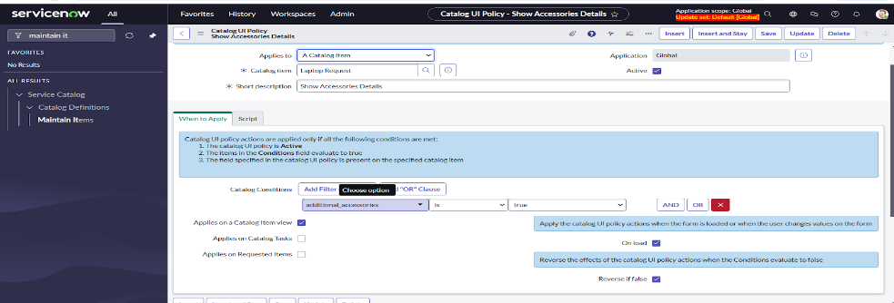                  [field: additional_ accessories, operator: is, value: true]

1. Click on **save**.(do not click on submit)
2. Scroll down and select ‘catalog ui action’
3. Then click on new button
4. Select variable name as: accessories_details

                              Order:100

                    Mandatory: True

                         Visible : True

1. 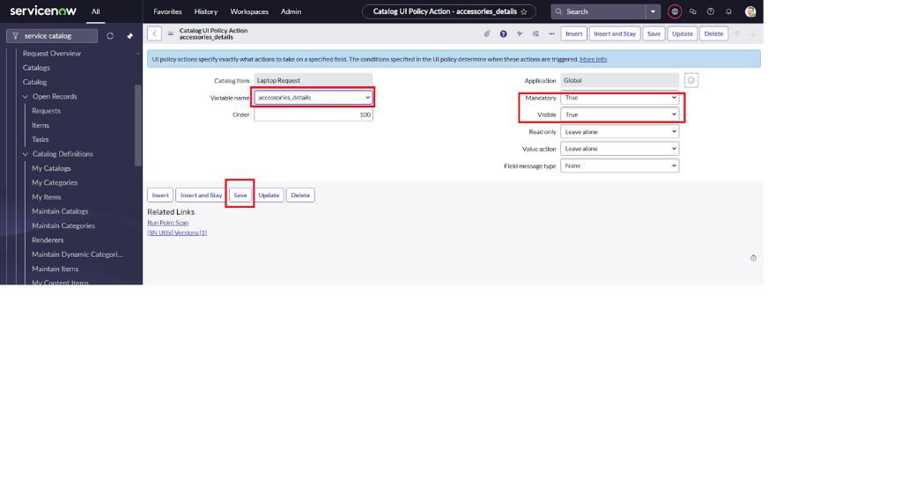Click on save and again click save button of the catalog ui policy form

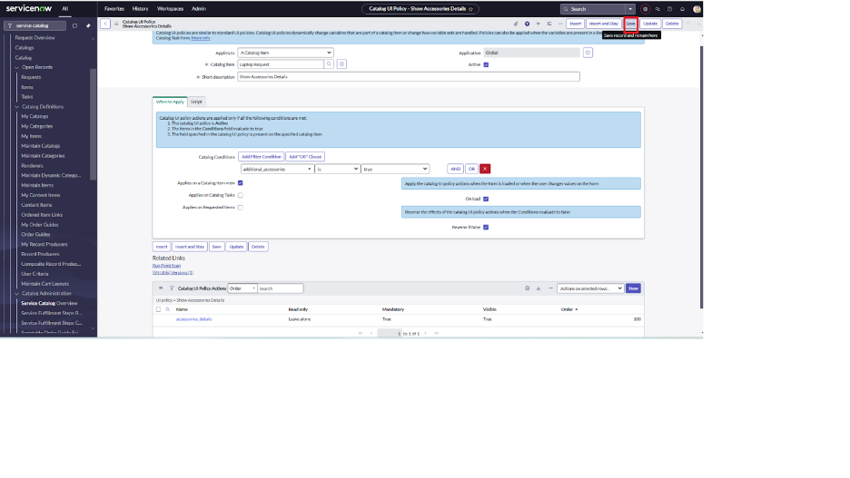

**UI Action:**

Create ui action

1. Open service now.
2. Click on All >> search for ui action
3. Select Ui actions under system definition
4. Click on new
5. Fill the following details to create ui action

              Table: shopping cart(sc_cart)  
              Order:100  
              Action name:  Reset form  
               Client: checked  
Script:  
    function reset Form () {  
    form. clear Form (); // Clears all fields in the form  
    alert ("The form has been reset.");  
}  
  
Click on save

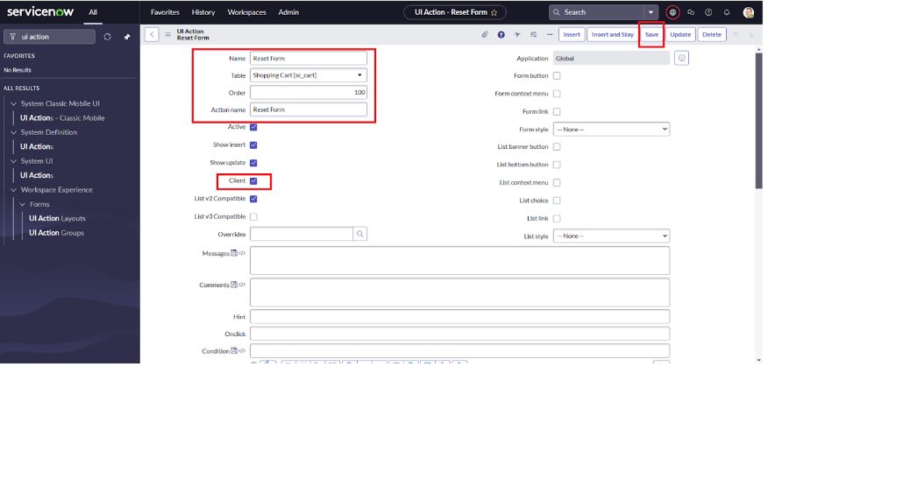

**Export Update set:**

Exporting changes to another instances

1. Click on All >> search for update sets
2. Select local update set
3. Select created update set i.e. ‘Laptop Request Project’
4. Set the state to ‘Complete’
5. In the related list Update tab, updates are visible which we perform under this update set.
6. 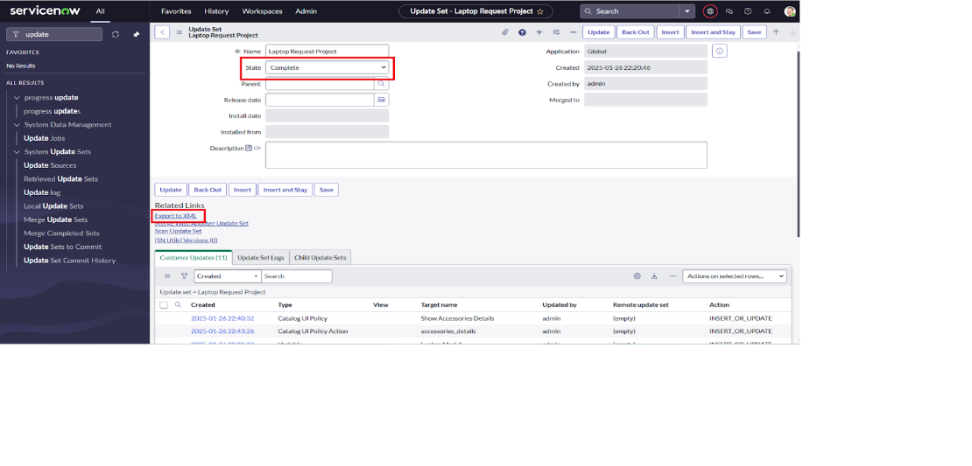Click on export to XML, it downloads one file

### **Login to another Instance:**

**Retrieving the update set**

1. Open another instance in incognito window
2. Login with credentials
3. Click on all>> search for update sets
4. Select “Retrieved update set” under system update set
5. It open retrieved update set list and scroll down
6. Click on Import update set from XML

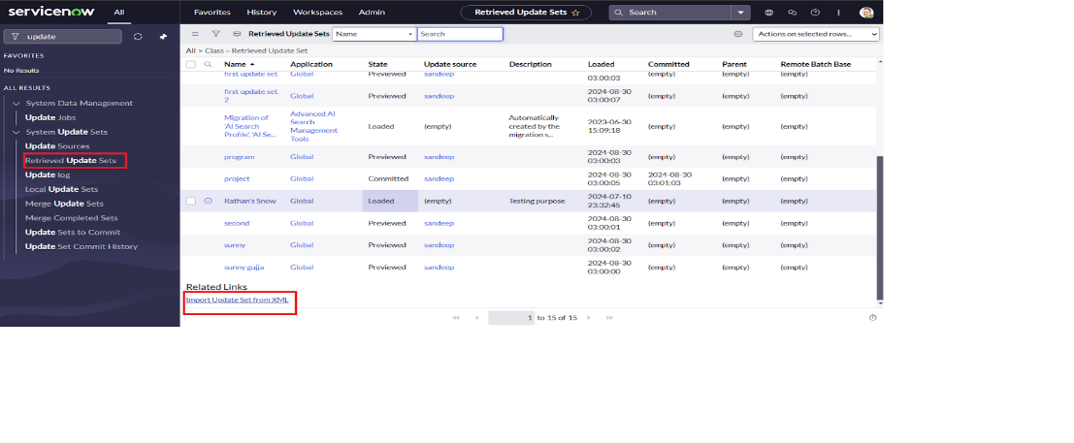

1. Upload the downloaded file in XML file
2. 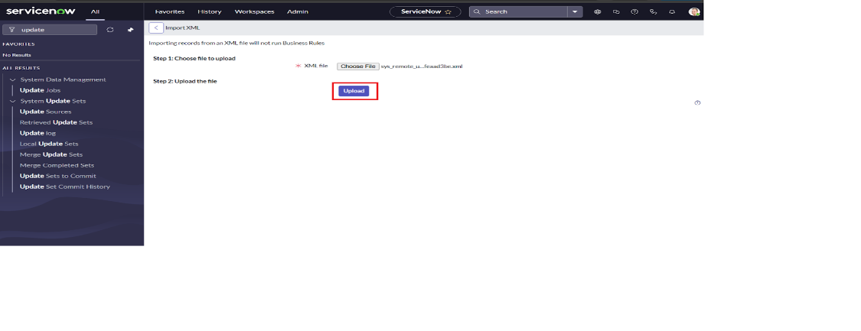Click on Upload and it gets uploaded
3. Open retrieved update set ‘laptop request project’
4. Click on preview update set
5. And click on commit update set
6. And also see the related tab updates
7. After commiting update set in this instance we get all updates which are done in the previous instance

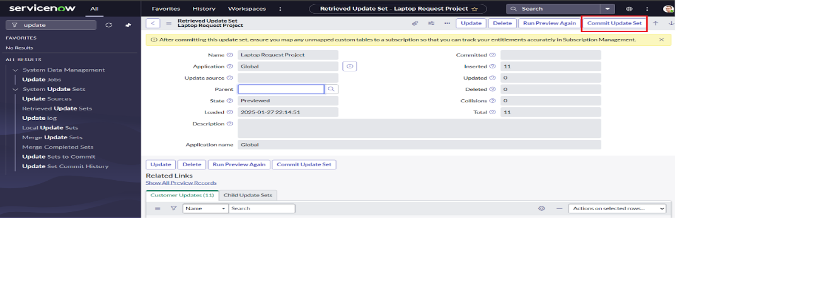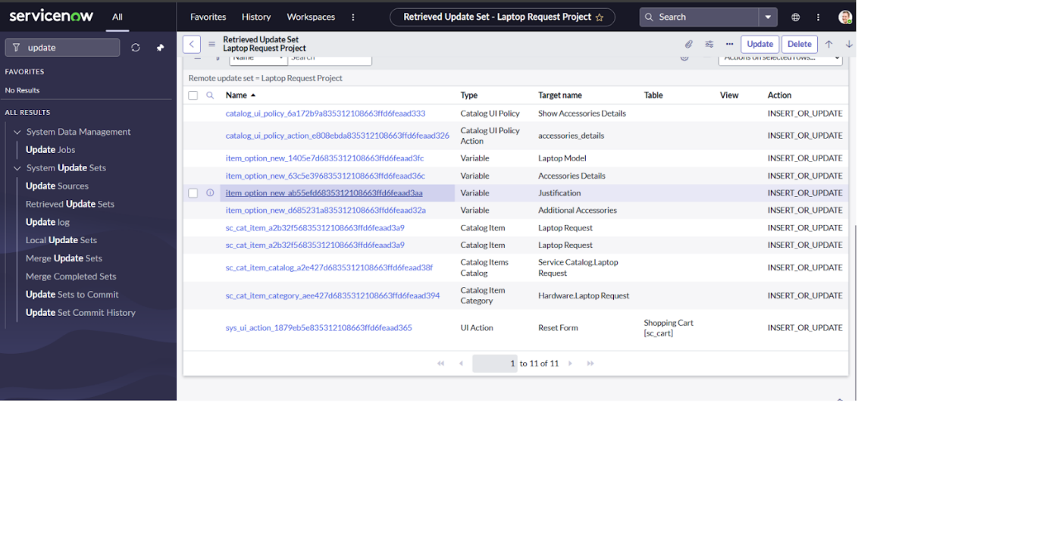

**Testing:**

Test Catalog Item

1. Search for service catalog in application navigator in target instance
2. Select catalog under service catalog
3. Select  hardware category and search for ‘laptop request’ item
4. Select laptop request item and open  it
5. 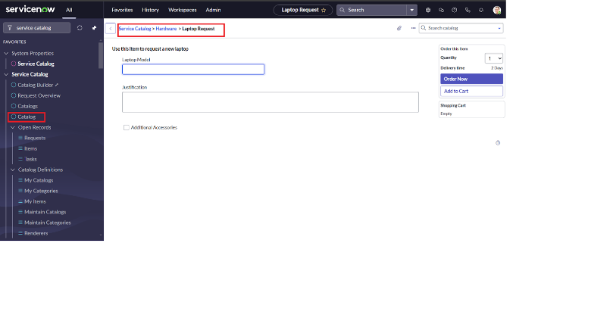It shows three variables only
6. As per our scenario, when we click on additional accessories checkbox then accessories details fields is visible and that should be mandatory
7. 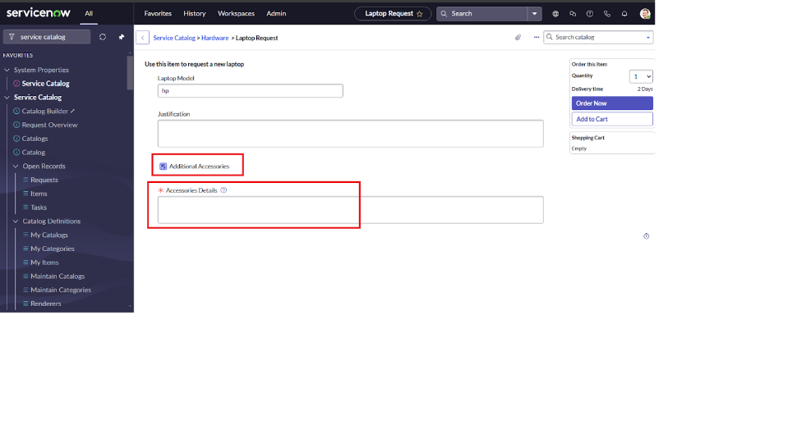Now  see the results,it fulfillsv our requirements.

## **Category:**

**ServiceNow System Administrator**

## **Skills Required:**

* Service Catalog
* UI Policies
* UI Actions

## **Problem Statement:**

**Currently, employees in the organization rely on a manual and inefficient process to request laptops, which results in several operational challenges. The lack of automation leads to significant delays in provisioning, causing frustration for end users and impacting productivity. Additionally, the absence of a structured digital form often results in incomplete or inaccurate data entry, which further complicates the approval and fulfillment processes.**

Create a **ServiceNow Catalog Item** with the following features:

### 1. **Catalog Item Name:**

**Laptop Request**

### 2. **Form Fields Of This Project:**

| **Field Name** | **Type** | **Description** |
| --- | --- | --- |
| Requested For | Reference (User) | Auto-populated with current user, editable |
| Laptop Type | Dropdown | Options: Standard, High-Performance, Custom |
| Operating System | Dropdown | Options vary based on laptop type |
| Justification | Multi-line Text | Reason for laptop request |
| Peripheral Requirements | Checkbox | Mouse, Keyboard, Dock, etc. |
| Manager Approval | Auto-generated | Triggered workflow (based on business rules) |
| Delivery Location | Text | User-provided delivery address |
| Reset Form Button | UI Action | Clears form inputs for re-entry |

### 3. **Dynamic Behavior** (Using UI Policies):

| **Condition** | **Action** |
| --- | --- |
| If Laptop Type is "Custom" | Show custom configuration fields |
| If Laptop Type is "High-Performance" | Auto-select OS as Windows/Linux only |
| If Peripheral Requirements is checked | Show options for peripherals |

### 4. **UI Actions:**

* **Reset Form**: Custom button to reset all fields to default
* **Submit**: Standard submit to trigger approval flow

### 5. **Workflows & Approvals:**

* Manager approval via Flow Designer / Workflow
* Optional: Auto-approval for standard laptops if below cost threshold
* Email notifications: submission, approval, fulfillment

### 6. **Governance & Tracking:**

* All changes captured in **Update Sets**
* Version control via **Scoped App or Update Set Naming**
* Changes submitted via **Change Management process**
* Auditing enabled for all configuration changes

## **Benefits:**

* Faster request fulfillment
* Fewer manual errors
* Clear, guided form experience
* Better tracking for approvals and governance
* Scalable and reusable Service Catalog framework

## **Supporting Artifacts:**

* Update Set: Laptop_Request_Catalog_v1
* Flow Designer Flow: Laptop Request Approval Flow
* Table(s) Involved: sc_req_item, sc_task
* Reference Catalog: Hardware Requests

## **Point of Contact:**

* **Developer:** [Your Name / Assigned Developer]
* **System Admin:** [Name]
* **Governance Lead:** [Name]

## **Conclusion of the project:**

The **Laptop Request Catalog Item** project provides a modern, efficient, and scalable solution to a previously manual and error-prone process within the organization. By leveraging **ServiceNow's Service Catalog capabilities**, along with **UI Policies**, **UI Actions**, and **approval workflows**, the solution ensures that employees can request laptops quickly, accurately, and with minimal administrative overhead.